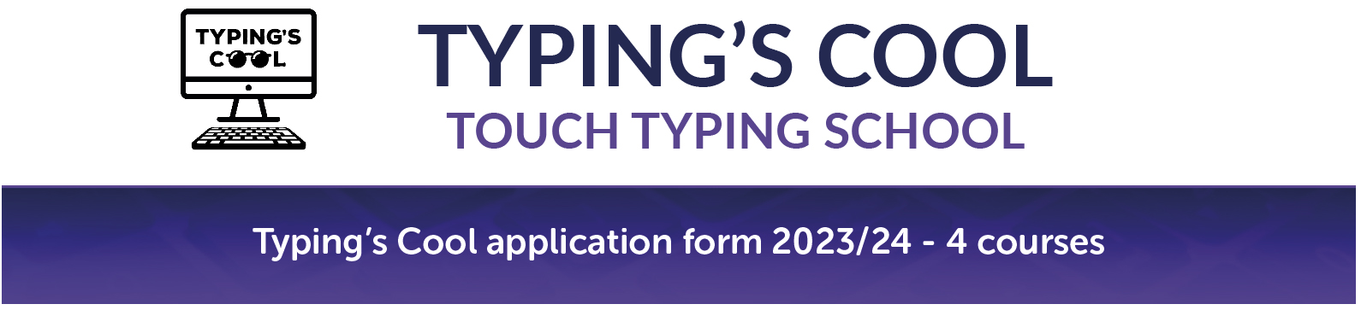
Please bold your chosen course(s) or tick if printing out
I would like to book my child(ren) onto the following course(s)
Christmas holiday 2023/24

All daily sessions run 10:00 – 12:15 pm
Mon 18 – Thur 21 Dec Dulwich College, SE21 7LD
Tues 2 - Fri 5 Jan 2024 St Joseph’s Primary School, Kingston KT1 2U

Spring half term 2024
Mon 12 – Thur 15 Feb Dulwich College, SE21 7LD
Mon 12 – Thur 15 Feb St Joseph’s Primary School, Kingston KT1 2U

Easter holiday 2024
Tues 2 – Fri 5 April Dulwich College, SE21 7LD
Tues 2 – Fri 5 April St Joseph’s Primary School, Kingston KT1 2UP
Mon 8 – Thur 11 April Dulwich College, SE21 7LD
Mon 8 – Thur 11 April St Joseph’s Primary School, Kingston KT1 2U

Summer holiday 2024
Mon 8 – Thur 11 July Dulwich College, SE21 7LD
Mon 8 – Thur 11 July Twickenham Prep School, TW12 2SA
Mon 15 – Thur 18 July Dulwich College, SE21 7LD
Mon 15 – Thur 18 July Twickenham Prep School, TW12 2SA
Mon 22 – Thur 25 July Dulwich College, SE21 7LD
Mon 22 – Thur 25 July St Joseph’s Primary School, Kingston KT1 2UP Mon 29 July – Thur 1 Aug Manor House School, Bookham, KT23 4EN
Mon 19 – Thur 22 Aug Dulwich College, SE21 7LD
Tues 27 – Fri 30 Aug St Joseph’s Primary School, Kingston KT1 2UP

Autumn half term 2024
Mon 28 – Thur 31 Oct Dulwich College, SE21 7LD
Mon 28 – Thur 31 Oct St Joseph’s Primary School, Kingston KT1 2U

Christmas holiday 2024
Mon 16 – Thur 19 Dec Dulwich College, SE21 7LD

How did you hear about us

Please bold your choices or tick if printing out
- My child’s school
- Google search
- Through another parent
Other – please state

Please bold your choices or circle if printing out

I give permission for photos to be taken of my child for the Typing’s Cool website and Facebook Yes / No
(Please note that no child will be individually tagged and photos will be anonymous)
Course to be attended In person Via Zoom
Child’s name
Child’s year group Child’s school
Home address
Postcode
Parent/ carer’s name
Parent/ carer’s email
Parent/ carer’s mobile
Sibling/ friend’s name (for discount on both places)
My child is a returner Yes / No
Are there any medical or special educational needs that the tutors should be aware of? Yes / No
If yes, please give details

Cost
One place - £176.00 Returning student - £158.00 2+ places - £158.00 per place
(10% Discount available for returners or booking for more than one student ie. Siblings or friends).
Examples - One student first time £176. One student previously attended £158. One student plus sibling £316

To book
Email (sarah.holt@typingscool.co.uk) or post the application form and payment to Typing’s Cool Ltd.
Nick and Sarah Holt, Typing’s Cool Ltd, School House, St Joseph’s Primary School, Fairfield, Kingston KT1 2UP
Payment can also be made by bank transfer to Typing’s Cool Ltd:
Sort code 09-01-27
Account number 44600440
Reference Child’s first and last name
Contact us
07812 632238
sarah.holt@typingscool.co.uk www.typingscool.co.uk facebook.com/typingscool

Company registered number: 7097313 OFSTED child care registered number: EY473171

